# Home Automation using Arduino and TSOP1738

Introduction

When power is applied the motor moves to 0o.

Now as button 1 is pressed from remote motor will move to 30o and likewise when button 2, 3, 4 or 5 is pressed motor will move to the desire angle 60o, 90o, 120o or 150o. The serial monitor also displays servo motor angle position as “servo motor angle xx deg”

• When volume up button is pressed, the motor angle increased by 5o – means if it’s on 30o, it will move to 35o and likewise. The new angle position is displayed on serial monitor.

• Similarly when volume down button is pressed, the motor angle decreased by 5o – means if it’s on 90o, it will move to 85o and likewise. The new angle position is displayed on serial monitor

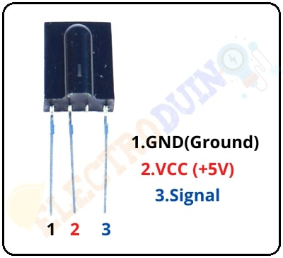**Components**

Arduino uno

Tsop 1738

Sg-90 micro servo motor

IR remote

**Application**

TV remote, Home theatre remote, AC remote

To control fan,bulb and lights

Security systems like object detection use it with the IR transmitter.

* TSOP1738 use in Line following robots to achieve its goal.

Hear Beat sensor can be built by using TSOP1738.

Objective

During this activity ,you will help students to achieve following objectives

1. Understanding the principle and operation of infrared sensor
2. Design algorithm and flowchart to detect IR light
3. Programming IR sensor using Arduino uno
4. Interfacing IR sensor withArduino uno

Program

#include <IRremote.h> // add IR remote library

#include <Servo.h> // add servo motor library

Servo servo1;

int IRpin = 12; // pin for the IR sensor

int motor_angle=0;

IRrecv irrecv(IRpin);

decode_results results;

void setup()

{

Serial.begin(9600); // initialize serial communication

Serial.println("IR Remote controlled servo motor"); // display message

irrecv.enableIRIn(); // Start the receiver

servo1.attach(5); // declare servo motor pin

servo1.write(motor_angle); // move the motor to 0 deg

Serial.println("Servo motor angle 0 deg");

delay(2000);

}

void loop()

{

while(!(irrecv.decode(&results))); // wait until no button is pressed

if (irrecv.decode(&results)) // when button is pressed and code is received

{

if(results.value==2210) // check if digit 1 button is pressed

{

Serial.println("servo motor angle 30 deg");

motor_angle = 30;

servo1.write(motor_angle); // move the motor to 30 deg

}

else if(results.value==6308) // if digit 2 button is pressed

{

Serial.println("servo motor angle 60 deg");

motor_angle = 60;

servo1.write(motor_angle); // move the motor to 60 deg

}

else if(results.value==2215) // like wise for all digit buttons

{

Serial.println("servo motor angle 90 deg");

motor_angle = 90;

servo1.write(motor_angle);

}

else if(results.value==6312)

{

Serial.println("servo motor angle 120 deg");

motor_angle = 120;

servo1.write(motor_angle);

}

else if(results.value==2219)

{

Serial.println("servo motor angle 150 deg");

motor_angle = 150;

servo1.write(motor_angle);

}

else if(results.value==6338) // if volume UP button is pressed

{

if(motor_angle<150) motor_angle+=5; // increase motor angle

Serial.print("Motor angle is ");

Serial.println(motor_angle);

servo1.write(motor_angle); // and move the motor to that angle

}

else if(results.value==6292) // if volume down button is pressed

{

if(motor_angle>0) motor_angle-=5; // decrease motor angle

Serial.print("Motor angle is ");

Serial.println(motor_angle);

servo1.write(motor_angle); // and move the motor to that angle

}

delay(200); // wait for 0.2 sec

irrecv.resume(); // again be ready to receive next code

}

}

###

Hardware• The sensor TSOP1738 has 3 terminals (1) Vcc (2) Gnd and (3) output. Its Vcc terminal is given 5 V from board and Gnd terminal is connected to ground of board. Sensor output is connected digital input pin 12 of arduino board

• Analog output pin 5 is connected to servo motor signal input pin to drive the motor

• The servo motor is given external 5 V supply

Motor is given supply from external 5 V and arduino board and IR sensor is given supply form USB.

